Bus Purchase Request System
  - Transit Organization Purchaser User Guide

Table of Contents
Using this guide 2
DES Bus Purchases contact information 2
Purpose of the system 3
Accessing the system 3
Browsers 3
Links 3
Obtaining access to the Bus Ordering system 3
Authentication 3
Navigation, Tooltips, Tables, and Required Fields 5
Navigation 5
Fields in BUS ORDERING 8
Tables in BUS ORDERING 8
Managing the User Profile 10
User Info 10
Saving your profile information 10
Purchase Requests 10
Purchase Request Overview 10
Requests 11
Initiating a new Purchase Request 11
Navigation on the Bus Purchasing Request screen 12
Bus Purchasing Request – Request and Contract Information 12
Bus Purchasing Request – Vehicle Information 13
Bus Purchasing Request – Contact Information 13
Bus Purchasing Request – Delivery Information 14
Bus Purchasing Request – Additional Information 14
Bus Purchasing Request – Purchase Request Files 14
Purchaser Dashboard table 14
Components of the Purchaser Dashboard tables 15
Review Bus Purchasing Request - Returned for Information 15
Bus Purchasing Request – Approved 16
Review Bus Purchasing Request – Approved 18
Navigation on the Bus Purchasing Request – Approved screen 18
Bus Purchasing Request – Vehicle Delivery Dates 18
Bus Purchasing Request-Purchase Order Files 19
Review Bus Purchasing Request – Awaiting Final Delivery Dates 19

Using this guide
To navigate easily through this guide, hold the Ctrl button and click on a heading in the Table of Contents.

DES Bus Purchases contact information

Contact Information
DES Bus Purchases
(360) 902-3560
buspurchases@des.wa.gov

Purpose of the system
The purpose of the BUS ORDERING system is to provide Transit Organization Purchasers with an intuitive and efficient system that streamlines the Bus purchasing request process.

Accessing the system
At this time, the Bus Ordering system is available only on computers, not mobile devices. Active Directory users must be connected by LAN (docked at your work desk) or connected to VPN in order to use the Bus Ordering System.

Browsers
Please use one of the following browsers to access the BUS ORDERING System: Chromium Edge (new Edge), Google Chrome, Firefox. BUS ORDERING may not function as intended in Internet Explorer or Microsoft Edge (old Edge).

Links
Production BUS ORDERING: https://apps.des.wa.gov/BUS ORDERING
QA BUS ORDERING (used for testing only): https://qaapps.des.wa.gov/BUS ORDERING

Obtaining access to the Bus Ordering system
To gain access to the BUS ORDERING system, contact DES Bus Ordering. Some initial information will be collected so that your user account can be established and appropriately configured.

Authentication
When you first access the Bus Ordering site at the link above, you will be prompted to authenticate with a Single Sign On (SSO) screen, which will contain a number of selections.

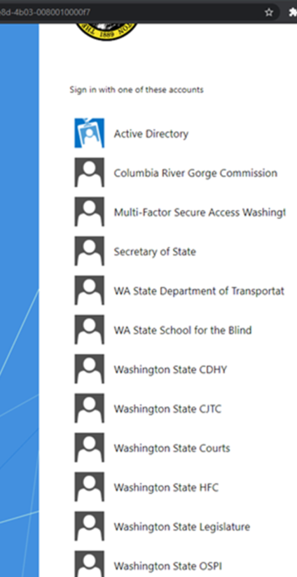

This screen may not appear every time you access Bus Ordering. If Active Directory or an agency option pertains to you, please select that option. Upon successful entry of your credentials, you will be routed to the Bus Ordering home screen. If you are unable to authenticate into the system successfully, please contact DES Bus Ordering , as they may need to obtain some additional information to set up your account, prior to you being able to successfully log in.

Users that do not have a selection on the SSO screen must get a Secure Access Washington with Multifactor Authentication (MFA-SAW) account. To obtain a MFA-SAW account, please access the SAW website and sign up for an account using the email address that you use for work, and to where you will receive Bus Ordering system notifications. Once you have a SAW account, return the information to the DES Bus Ordering team. Once you are added to the system, navigate to the Bus Ordering website and you will be presented with the SSO screen (as seen above) again. Select Multi-Factor Secure Access Washington, and you will be routed to the SAW website where you will be prompted to add Multi-factor Authentication to your SAW account, if you do not already have it. Once you have added MFA to your SAW account, or you enter your MFA-SAW credentials if you already had an account established, you will be routed back to the Bus Ordering website.

Please note that your session in BUS ORDERING will expire after 20 minutes. After that time, you will need to refresh your browser and may need to login again.

Navigation, Tooltips, Tables, and Required Fields

Navigation
To navigate throughout the system, use the left-hand navigation menu. The menu may look different based on your user profile:

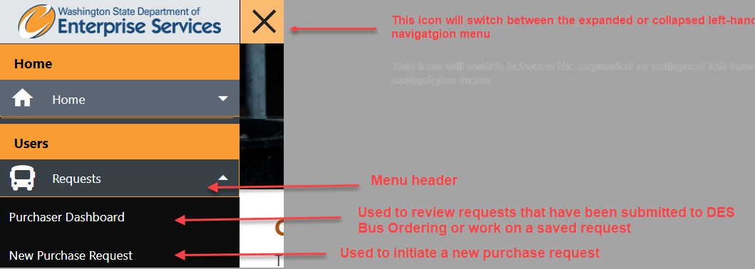

To expand the menu, click the icon. To collapse the menu, click the icon.

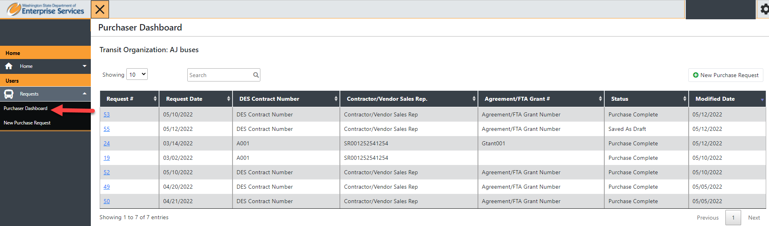

- The Requests > Purchaser Dashboard menu option will direct you to a screen that contains:
  - The Purchaser Dashboard table displays requests that have been Saved As Draft, submitted to DES Bus Purchasing and are going through the process, Completed or Cancelled requests
  - You can review, edit, and delete saved requests (requests that have not yet been submitted). You can also initiate a new purchase request

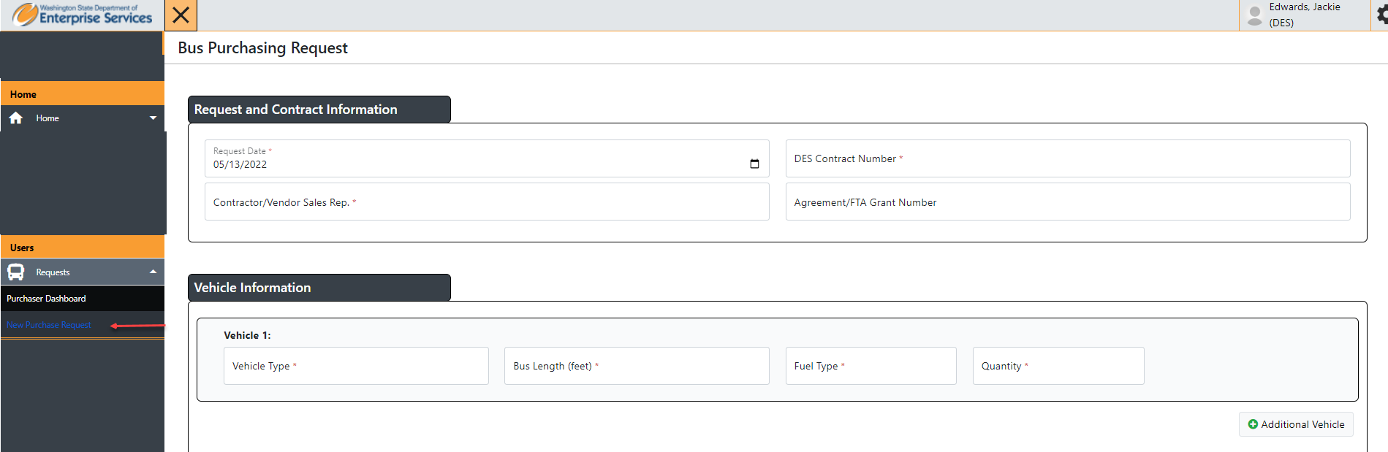

- The Request > New Purchase Request menu option will direct you to a screen that displays the Bus Purchasing Request form

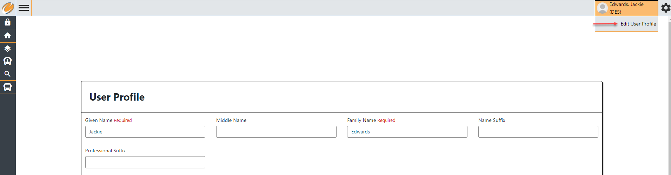
- The Manage Profile > User Profile menu option will direct you to a screen where you can manage your contact information

Fields in BUS ORDERING
Throughout the BUS ORDERING system, you will see the tooltip icon 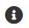. Hovering over this icon will give you more information about the field.

Required fields are indicated with an asterisk * or Required

Tables in BUS ORDERING
There are many tables in the BUS ORDERING system, and they function in a consistent manner.

- To filter the information in a table, begin typing in the “Search” text box in the upper left-hand corner of the screen, for example:
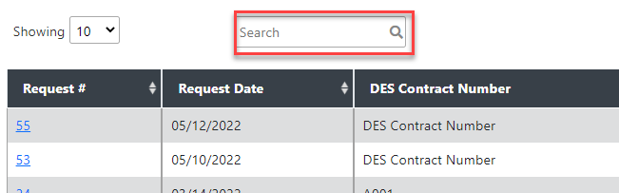

- You can sort the information by any column in a table by clicking on the arrows next to the column title. Click again to reverse the sort order. Hold shift and click on the column headers to sort by multiple columns at once.

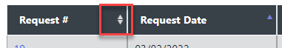

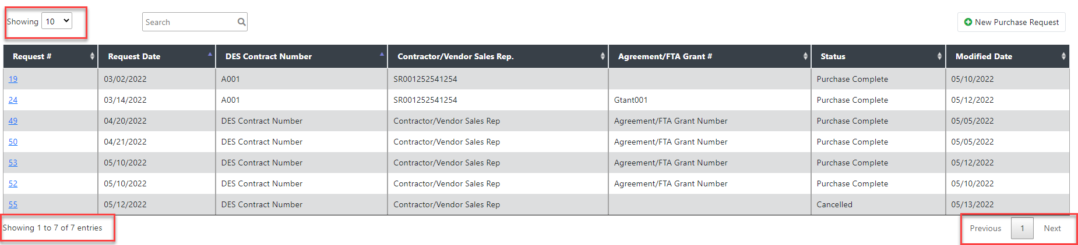
Show # entries: Just above the table, you can change the number of entries that you see in the table.
Previous and Next Pages: Use these buttons to navigate through the entries in the table if you have more than one page of entries.

Managing the User Profile
To navigate to your User Profile, click the Edit User Profile under your name in the upper right-hand corner. Your name comes from Active Directory or SAW.

User Info
The User Info section contains information about your BUS ORDERING account:

Given Name*: Required field; please enter your first name.
Middle Name: Enter a middle name if you use one. If not leave blank.
Family Name*: Required field; please enter your last name.
Name Suffix: Enter a name suffix if you use one. If not leave blank.
Professional Suffix: Enter a professional suffix if you use one. If not leave blank.
Phone*: Required field; please enter the phone number at which you would like to be contacted for BUS ORDERING-related content, such as questions about your purchase requests.
Email*: Required field; please enter an email address you would like to be contacted for BUS ORDERING-related content, such as questions about your purchase requests.
Title: Enter a title if you use one. If not leave blank.
Agency*: Required field; please enter an agency or Transit Organization that you work for.
Department*: Required field; please enter the Department that you work for.

Saving your profile information
To save the changes that you made to your User Info, click the Update Profile button beneath the User Info section.

Not all fields will be populated with information. If you update any fields on the screen, you will be required to enter all the required information. Prompts will appear for missing required fields or fields filled out incorrectly.

Purchase Requests

Purchase Request Overview

The Purchase Request process is a multi-step process. Create Purchase Request, Submit Purchase Request for Approval, Submit Pending Delivery Dates and Purchase Request file, and Submit Final Delivery Dates, Cost and Purchase Order files. Alternate steps may include Deleting a draft request, Cancelling a request, Request for More Information

Requests
The Purchaser Dashboard screen is a location to begin a new Request, review your list of Requests that have not yet been submitted to Procurement Specialist, and to proceed to submitting your request. To access the Purchaser Dashboard screen, click the Requests heading in the left-hand menu, then click Purchaser Dashboard:

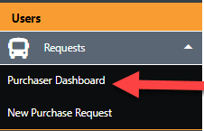

Purchaser Dashboard table

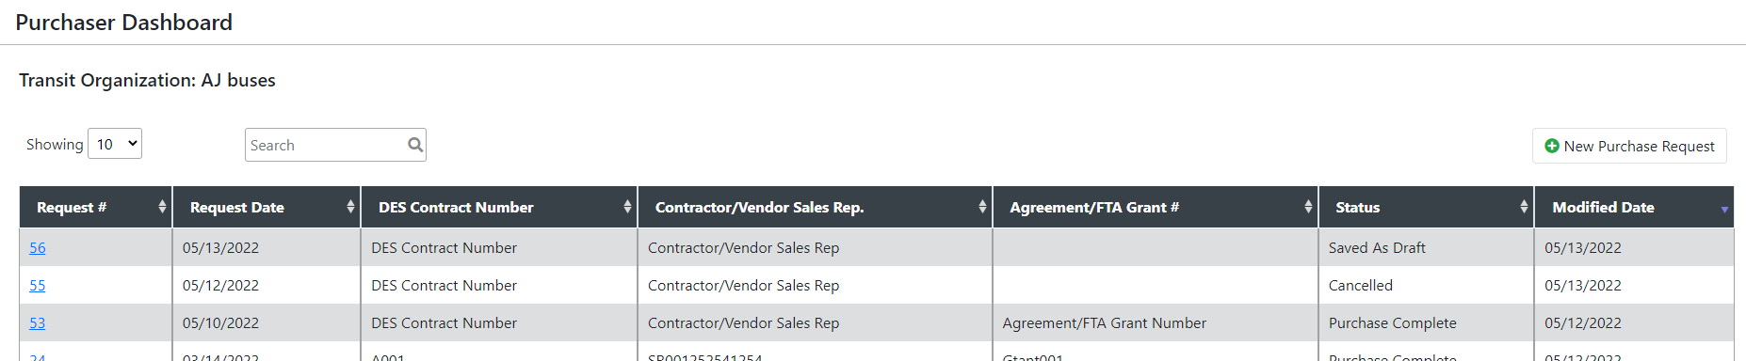

Components of the Purchaser Dashboard tables
Request #: Each Request has a unique Request #, it will display here
Request Date: The date the request was created.
DES Contract Number: The Transit Bus Contract Number
Contractor/Vendor Sales Rep: The Contractor/Vendor Sales Rep you are purchasing from
Agreement/FTA Grant#: The Agreement/FTA Grant# being used, if applicable
Status: The status of the request. Possible status’ include – Saved As Draft, Approved, Pending Purchase Order Review, Awaiting Final Delivery Dates, Completed, Cancelled
Modified Date: The date the request was last modified

Initiating a new Purchase Request
To begin a new Request, click the New Purchase Request button in the upper right-hand corner of the Purchaser Dashboard screen:

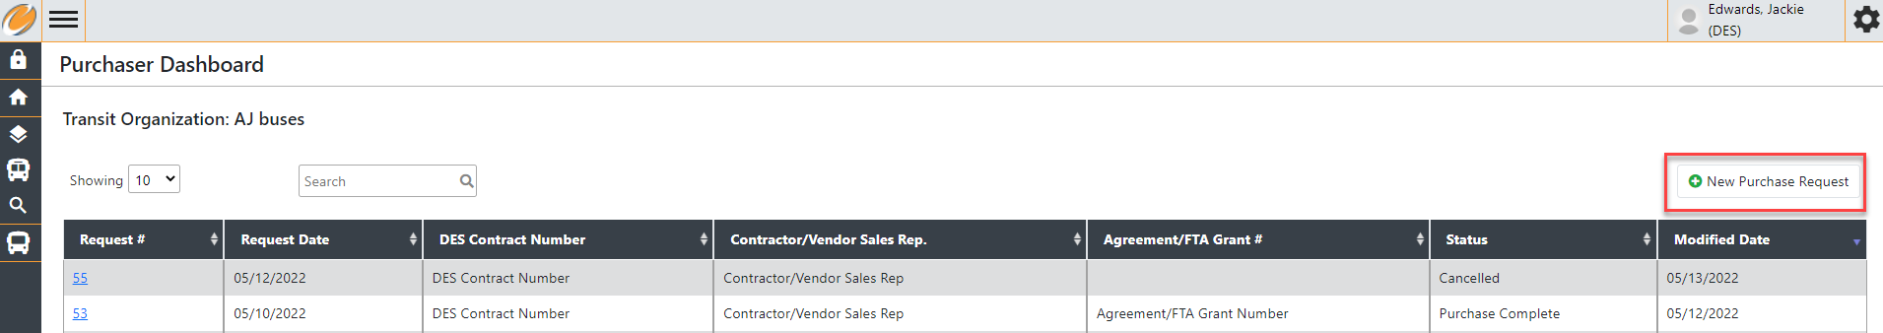

Or in the middle of the HomePage screen:

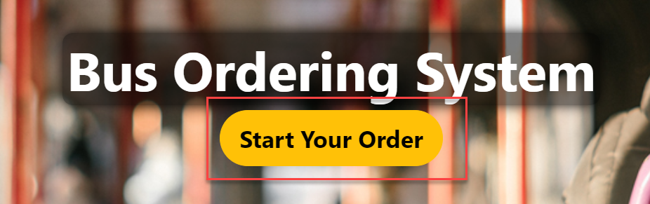

The Bus Purchase Request form is broken into different sections: 1) Request and Contract Information, 2) Vehicle Information, 3) Contact Information, 4) Delivery Information, 4) Additional Information and 5) Purchase Request Files.

Navigation on the Bus Purchasing Request screen

Cancel: Displays in the lower left-hand corner of the screen; cancels changes made in the form. Clicking this button will return you to the Purchaser Dashboard screen.
Save as Draft: Displays in the bottom middle right-hand corner of the screen; saves your Request without validating the information entered. Use this button if you need to save your place and return to the Request at a later time. Clicking this button will return you to the Purchaser Dashboard, where you will see your request with a status of Saved as Draft.
Submit: Displays in the lower right-hand corner of the screen; this button will validate the information and submit the request. If information has been entered incorrectly, or required fields are missing, you will receive an error notification that will direct you to correct the information.

Bus Purchasing Request – Request and Contract Information

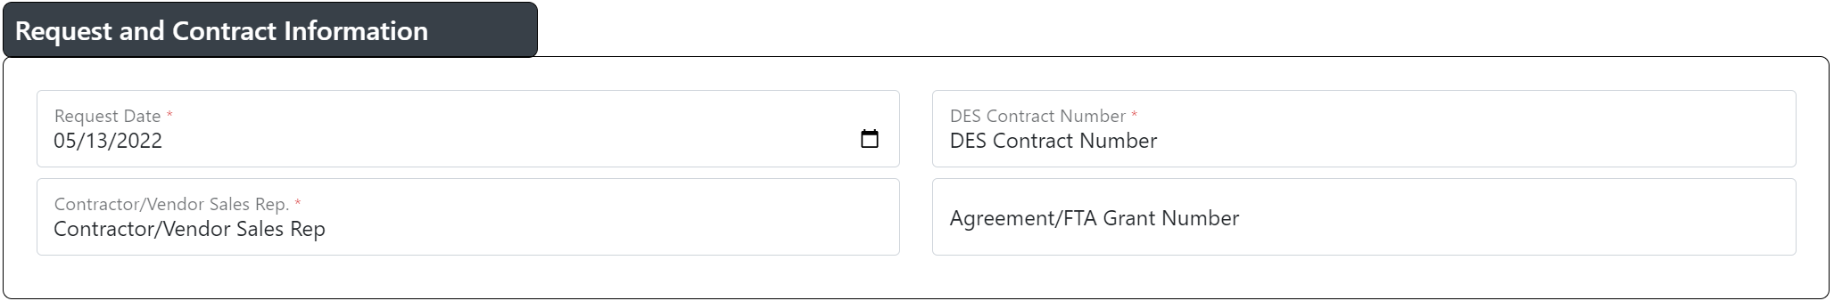
Request Date*: The date the request was created
DES Contract Number*: The Transit Bus Contract number
Contractor/Vendor Sales Rep*: The contractor/vendor sales rep you are purchasing from
Agreement/FTA Grant Number: The agreement or FTA Grant number being used, if applicable

Bus Purchasing Request – Vehicle Information
Vehicle Type*:
Bus Length (feet)*:
Fuel Type*:
Quantity*:

Bus Purchasing Request – Contact Information
Contact Name*: The name of the person who will be contacted for any questions regarding the purchase request
Contact Phone Number*: The phone number of the Contact listed
Contact Email*: The email of the Contact listed

Bus Purchasing Request – Delivery Information
Address*: The address where the bus(es) will be delivered
City*: The city of the address where the bus(es) will be delivered
Select State*: The state of the address where the bus(es) will be delivered
Zip Code*: The zip code of the address where the bus(es) will be delivered

Bus Purchasing Request – Additional Information
Total Estimated Cost*:
Comments: Any comments you want to add in regard to the request. This will be visible to anyone with access to the purchase request.

Bus Purchasing Request – Purchase Request Files
Choose Files: Allows the user to browse to and select documents to add to the Bus Purchasing Request. At least one document is required to be added prior to submitting.
Clear File Selection: Allows the user to clear the selected files prior to submitting

Bus Purchasing Request - Returned for Information
When a Bus Purchasing Request is returned for information, you will receive an email notification
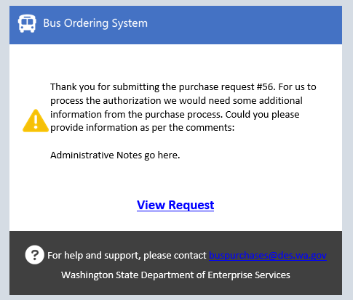

The status on the Purchaser Dashboard will be changed to Returned for Information and you will see an additional field
Administrator Notes: This is where you will see notes when a request is returned for information.
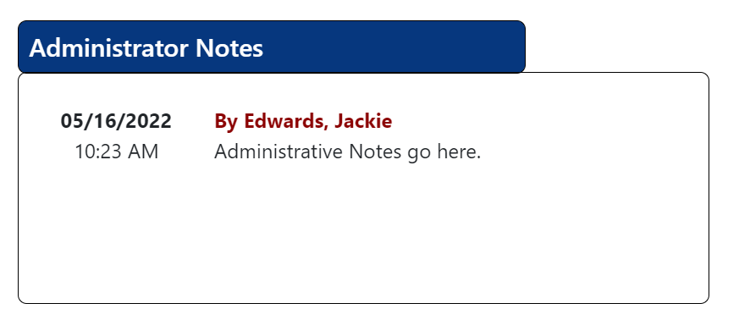

Bus Purchasing Request – Approved
When the Procurement Specialist approves your request, you will receive an email notification of the approval
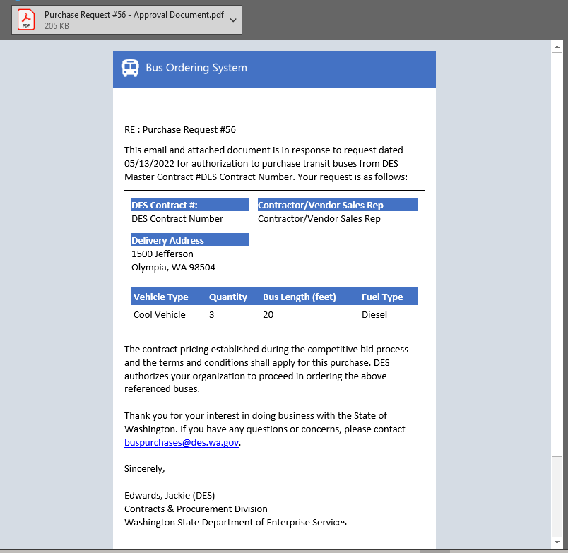
The status on the Purchaser Dashboard will be changed to Awaiting Purchase Order

Navigation on the Bus Purchasing Request –(Approved) screen

Cancel: Displays in the lower left-hand corner of the screen; cancels changes made in the form. Clicking this button will return you to the Purchaser Dashboard screen.
Submit: Displays in the lower right-hand corner of the screen; this button will validate the information and submit the request. If information has been entered incorrectly, or required fields are missing, you will receive an error notification that will direct you to correct the information.

You will see an additional Tab on the Bus Purchase Request

Purchase Information
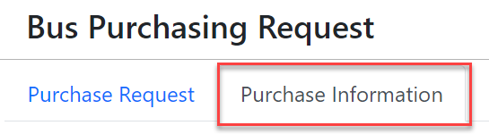
And additional sections on the Purchase Information Tab

Bus Purchasing Request – Vehicle Delivery Dates
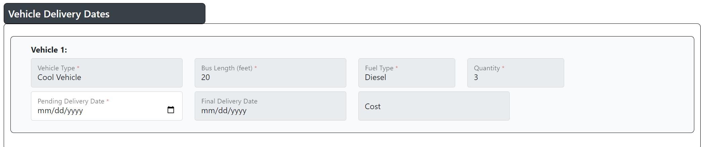
Vehicle Type*:Read only
Bus Length (feet)*: Read only
Fuel Type*: Read only
Quantity*: Read only
Pending Delivery Date*: The expected date of delivery for the bus(s) being ordered. Required prior to submitting
Final Delivery Date: Read only
Cost: Read only

Bus Purchasing Request-Purchase Order Files
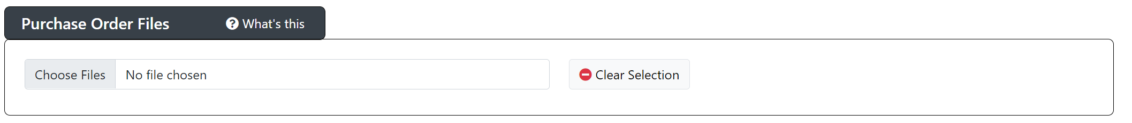
Choose Files: Allows the user to browse to and select documents to add to the Bus Purchasing Request. At least one document is required to be added prior to submitting.
Clear Selection: Allows the user to clear the selected files prior to submitting

After submitting the request the status will be changed to Pending Purchase Order Review while the Procurement Specialist reviews for approval

Bus Purchasing Request – Awaiting Final Delivery Dates
After the Purchase Order has been approved by the Procurement Specialist the status will be changed to Awaiting Final Delivery Dates

You will see additional fields on the Bus Purchase Request-Purchase Information Tab:

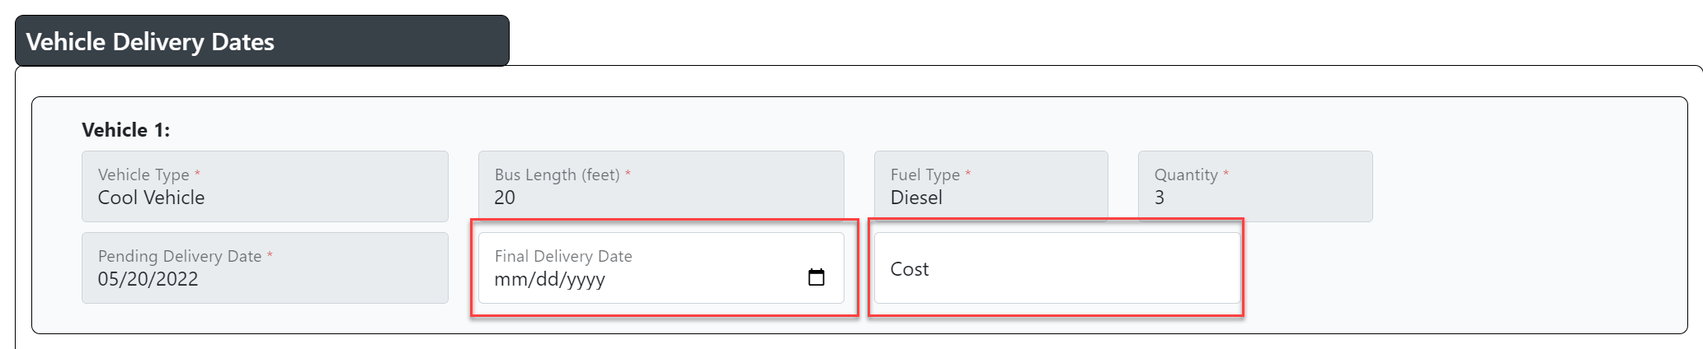
Final Delivery Date: The date that final bus is delivered (if the quantity is more than 1 only add the date of the last vehicle that is delivered)
Cost: The total cost of all vehicles that have been delivered

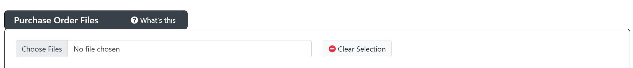

Choose Files: Allows the user to browse to and select documents to add to the Bus Purchasing Request. At least one document is required to be added prior to submitting.
Clear Selection: Allows the user to clear the selected files prior to submitting

If more than one quantity has been ordered for the vehicle type, you can attach the Purchase Order for that vehicle and submit as these are received. Once the last vehicle is delivered for that vehicle type you will want to add the Final Delivery Date and Cost and attach the final Purchase Order to the request and submit.

If more than one vehicle type is ordered, you will need to do this process for each vehicle type and quantity. Once all vehicles have been delivered and the Final Delivery Date and Cost is added for all vehicle types and you submit, the status will be changed to Purchase Complete, and the purchase request will be changed to read only. If more information is needed you will receive an email from the Procurement Specialist requesting the information and they will be able to add the information to the Purchase Request.

